# Installing Anaconda on

# Windows Tutorial

Download and Install Anaconda

Go to Anaconda Website:

1. **https://www.anaconda.com/**
2. Locate your download and double click it.



Once it clicked it will take you to another page like below:

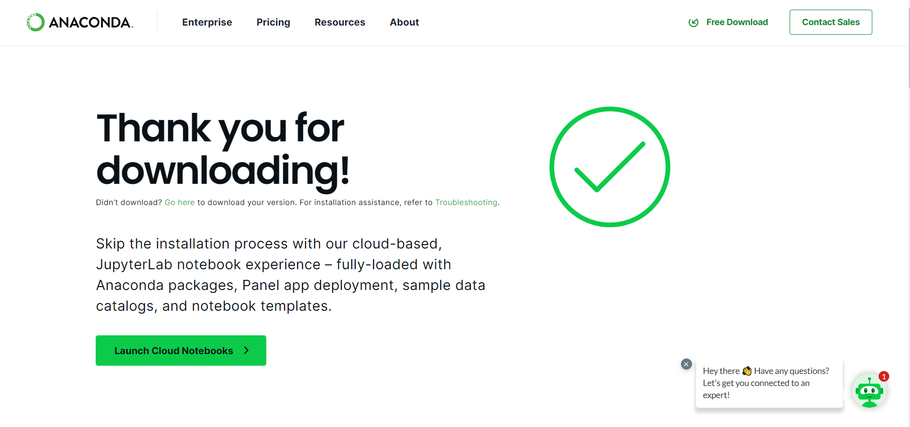

Check chrome downloads (Ctrl +J). Once it downloaded check your folder (Win + E)  
  
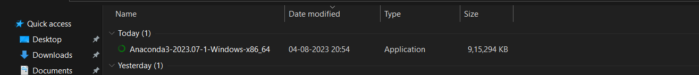

Double Click on it. It will take you to the installation page.

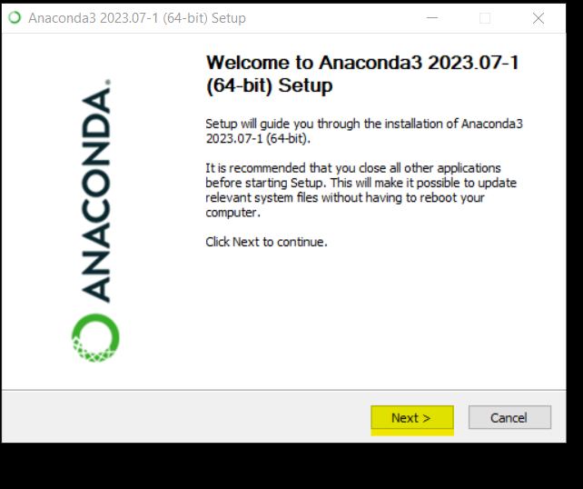  
  
Click on next button

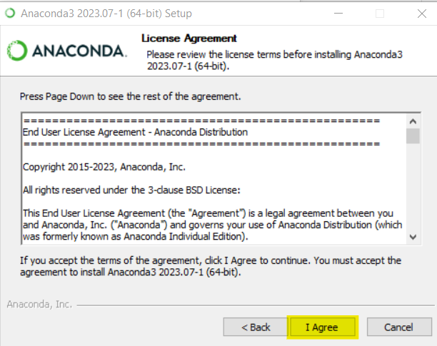

Click on I Agree button.

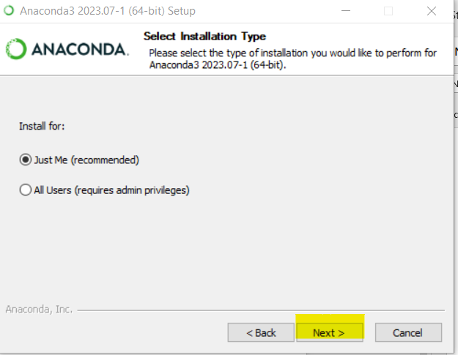

Click next button..

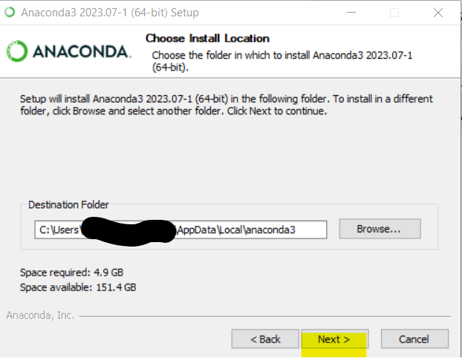

Click Next button..

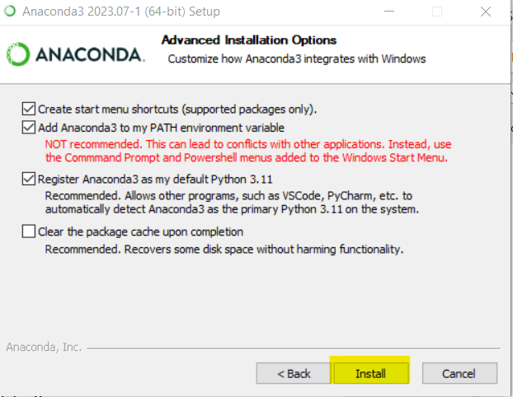

Cross check all three boxes are checked and click Install…

Wait some time until it gets installed.